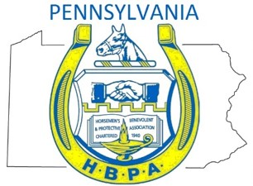

Dear PA HBPA Members,

State legislators in Harrisburg are trying to amend the Gaming Act with a bevy of gambling expansion ideas that would drive people away from horse racing facilities.
We need your help! Make your voice heard! Download a form letter on our website: www.pahbpa.com-- and send it to your legislator today!
The letter makes it clear that expanded gaming is wrong – and that it will hurt a growing horse racing industry that has created 23,000 jobs and invests millions into local communities and farms every year!
If you don't know who your legislators are, you can find them here:
www.legis.state.pa.us/cfdocs/legis/home/findyourlegislator/
For more information, here is a link to the legislation:
www.legis.state.pa.us/cfdocs/billInfo/billInfo.cfm?sYear=2015&sInd=0&body=H&type=B&bn=1925
As you know, expanded gaming in Pennsylvania could only be enacted when the state partnered with the agricultural community to ensure the horse racing industry stayed intact. It's a partnership that aimed to preserve our farms, our workers, our veterinarians and all facets of the industry that support our racetracks. The law worked. Today, our industry has created 23,000 jobs, features some of the best horses in the world, is investing millions into the Pennsylvania economy, and is helping to preserve thousands of acres of open farmland.
But if some legislators have their way, they'll expand gaming practically everywhere to include liquor establishments, fire halls, truck stops, video gaming terminals in taverns and more. There's even a plan to allow for internet gaming at a much lower tax rate. That means casinos with racetracks are more likely to market internet gaming at the expense of our racetracks!
We must act now! Contact your local legislators today and tell them to oppose legislation that would expand gaming and hurt Pennsylvania's horse racing industry.

Let's stand together.
Sincerely,
PA HBPA

