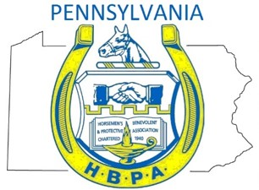

Dear Rep. ___________________:

Thank you for your leadership!

I’M WRITING TO ASK THAT YOU OPPOSE ALL MEASURES THAT WOULD EXPAND GAMING, INCLUDING INTERNET GAMING, THAT WILL HURT OUR RACETRACK INDUSTRY!

With internet gaming comes a lower tax rate. This is important because we believe casinos will market to internet gamers, rather than encourage attendance at racetracks. That means less taxes for property tax relief – and less revenue for Pennsylvania’s Horse Racing Fund. That will hurt working families, retirees and seniors on fixed incomes, thousands of horse racing employees, and farmers who count on selling goods and services to the industry.

As you know, expanded gaming in Pennsylvania aimed to preserve our farms, grow and expand jobs, and enhance all facets of the industry that support our racetracks. The law worked. Today, our industry has created 23,000 jobs, features some of the best horses in the world, is investing millions into the Pennsylvania economy, and is helping to preserve thousands of acres of open farmland.
Pennsylvania can be proud of the work its horse racing industry has done since gaming expansion was passed over a decade ago. Now, we’re asking that you protect it.

Please protect 23,000 jobs!

Please protect property tax relief generated by slots revenue!

Please protect farmers who depend on our industry!

Please oppose ALL gaming expansion!

Sincerely,

